Hellenic Accreditation System
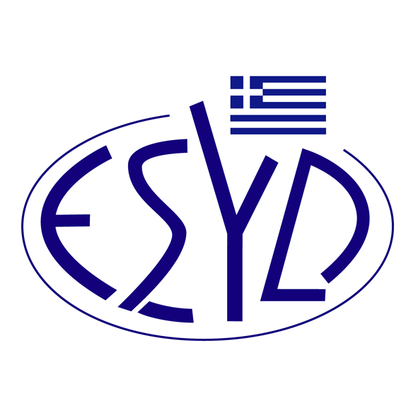

Annex G1/6 to the Certificate No. 466-2

SCOPE of ACCREDITATION
of the
Biochemistry Department
of the
Laboratories Division
of
KONSTANTOPOULEIO General Hospital of N. Ionia

Tested materials/ products | Types of test/ Properties to be measured | Applied Standards/ Techniques to be used
Biochemical Tests
1. Blood Serum | Determination of 9 parameters | Automated biochemical analyzers Dimension 1,2,3,4 (Siemens)*
1. Blood Serum | 1. Alkaline phosphatase (ALP) | Enzymatic p-NPP, p-NP
1. Blood Serum | 2. Glutaminic-pyruvic transaminase (AST) | Enzymatic / aKG, P5P, NaDH+ / NAD+
1. Blood Serum | 3. Glutaminic-oxaloacetic transaminase (ALT) | Enzymatic / L-aspartate + a-ketoglutarate / NADH / NAD
1. Blood Serum | 4. Creatinine kinase (CKI) | Enzymatic ADP, ATP / NADP+ NADPH
1. Blood Serum | 5. Creatinine Kinase, MB fraction (CPK-MB) | Enzymatic ADP, ATP / NADP+ NADH
1. Blood Serum | 6. Gamma-glutamyl transferase (GGT) | Enzymatic GCNA, glycyloglycine
1. Blood Serum | 7. Total bilirubin (TBiLi) | Sulph acid dpi/carf-benz
1. Blood Serum | 8. Magnesium (Mg) | Chromogenic MTB
1. Blood Serum | 9. Albumin (ALB) | BCP
1. Blood Serum | Determination of 1 parameter | Automated biochemical analyzers Dimension 2,3,4 (Siemens)*
1. Blood Serum | 1. Troponin I (cTnI) | LOCI
2. Blood serum and urine | Determination of 10 parameters | Automated biochemical analyzers Dimension 1, 2,3 (Siemens)*
2. Blood serum and urine | 1. Αmylase (AMY) | Enzymatic /CNPG-3 CNP
2. Blood serum and urine | 2. Urea (BUN) | Enzymatic /urease NAD
2. Blood serum and urine | 3. Calcium (Ca) | Chromogenic / OCPC
2. Blood serum and urine | 4. Creatinine (CREA) | Jaffe Modified kinetic
2. Blood serum and urine | 5. Phosphorus (PHOS) | Phosphomolyb formation
2. Blood serum and urine | 6. Uric acid (URAC) | Enzymatic (Uricase)
2. Blood serum and urine | 7. Potassium (K⁺), Sodium (Na⁺), Chloride (Cl⁻) | Intergrated Multisensor Technology (IMT)
3. Blood serum, CSF and other biological fluids | 8. Glucose (Gluc) | Enzymatic (HK/G-6-P/NAD⁺/NADH)
3. Blood serum, CSF and other biological fluids | 9. LDI | Chromogenic Lactate → pyruvate
4. Blood serum and other biological fluids | 10. Total Protein (TP) | Chromogenic modified reaction biuret
5. Blood Serum | Determination of 4 parameters | Automated biochemical analyzers Dimension 1,2,3 (Siemens)*
5. Blood Serum | 1. Iron (Fe) | Chromogenic
5. Blood Serum | 2. High-density lipoprotein cholesterol (HDL) | Selective immune interference Enzymatic Chromogenic
5. Blood Serum | 3. Triglycerides (TGL) | Enzymatic GPO-POD
5. Blood Serum | 4. Total Cholesterol (CHOL) | Chromogenic
6. Whole blood | Determination of 1 parameter | Automated biochemical analyzers Dimension 4 (Siemens) *
6. Whole blood | 1. Glycated Haemoglobin (HbA1C) | Turbidimetric immunoenzymatic (TINIA)
Immunochemical Tests
1. Blood Serum  Blood Serum (continued) | Determination of 9 parameters | Automated immunochemical analyzer CENTAUR XP (Siemens) *
1. Blood Serum  Blood Serum (continued) | 1. Triidothyronine total (Total T3) | Chemiluminescense (CLIA)
1. Blood Serum  Blood Serum (continued) | 2. Thyroxin total (Total Τ4) | Chemiluminescense (CLIA)
1. Blood Serum  Blood Serum (continued) | 3. Free Triidothyronine (Free T3) | Chemiluminescense (CLIA)
1. Blood Serum  Blood Serum (continued) | 4. Free Thyroxin (Free-T4) | Chemiluminescense (CLIA)
1. Blood Serum  Blood Serum (continued) | 5. Thyrotropin Hormone (TSH) | Chemiluminescense (CLIA)
1. Blood Serum  Blood Serum (continued) | 6. Total Human Chorionic Gonadotropin (T-ΗCG) | Chemiluminescense (CLIA)
1. Blood Serum  Blood Serum (continued) | 7. Prostate Specific Antigen (PSA) | Chemiluminescense (CLIA)
1. Blood Serum  Blood Serum (continued) | 8. Free Prostate Specific Antigen (FPSA) | Chemiluminescense (CLIA)
1. Blood Serum  Blood Serum (continued) | 9. Ratio Free/Total PSA | Chemiluminescense (CLIA)
*Reference to the commercial name of a specific analyzer, refers to a specific analytical method and protocol

Site of assessment: Laboratory permanent premises: 3-5 Aghias Olga str., 14233 N. Ionia, Greece
Approved signatories: P. Paraskevopoulou, C. Lougovoi, E. Kastrinelli, I. Manolis, A. Tsirigotis, S. Garyfallidis.

This Scope of Accreditation replaces the previous one dated 28.01.2013.
The Accreditation Certificate No.466-2, to ELOT EN ISO 15189:2007, is valid until 05.11.2016.

Athens, September 22, 2014

Ioannis Sitaras
Director of the Laboratories Accreditation Division

